Members: Kyle Fuson, Steven Bissell, and David Milostan

**ISP Final Report**

The project has a fully implemented image storing/viewing application. Anyone that uses the website will be able to create an account, upload any JPG picture, and be able to view a library of pictures that they have uploaded. The website is built with html, php, css, and SQL. We deployed our database using mysql on the university’s database that was provided to us. We hosted our website through pausch.

We ran into difficulty on trying to display the images after we upload them. It took us a lot of reading documentation on mysql commands and php tutorials until we were finally able to retrieve the image we stored and view it. Once we were able to view our image, we tried to get it so we can view the other images we uploaded as well. The main issue we had here was that we were trying to use fetch_array instead of fetch_array_all, so since we weren’t using the all one we had a duplicate picture repeating since it was only retrieving the one. We learned that storing images has to be done with blob files because that is the only effective way to actually store an image in a database.

Future work includes the option to view other people uploads that they made public. Once the picture was made public, people can post comments and like the picture. We would like to expand the design even further to include video storage as well. Basically we would like to recreate Instagram for our future work. That would allow us to essentially follow other users to see what they upload and then comment and like if we choose to.



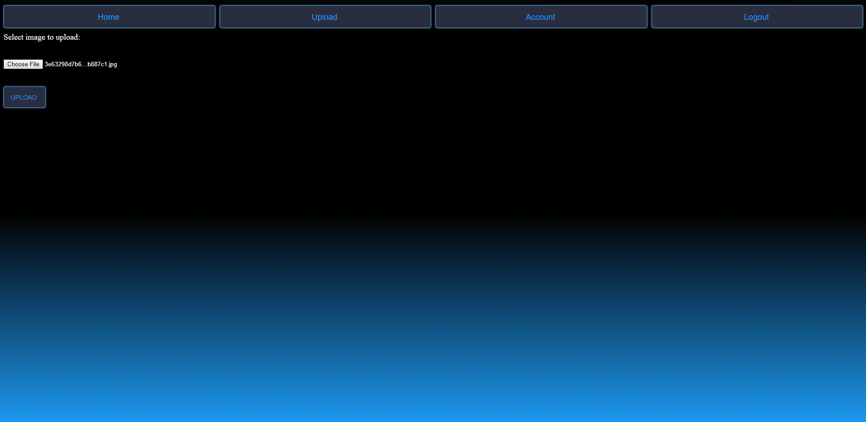

Kyle created the database side of things. He added the tables needed to make the upload and retrieve work. He also helped debug the image viewing on the website, as we ran into a lot of problems with that at first. He made sure that any thing on the database side was properly configured the way we needed it to be and created tables as we progressed. Kyle also did thorough testing of all the functions to ensure that they were all working prior to the demo. Kyle wrote up the online technical document and helped write the final report as well.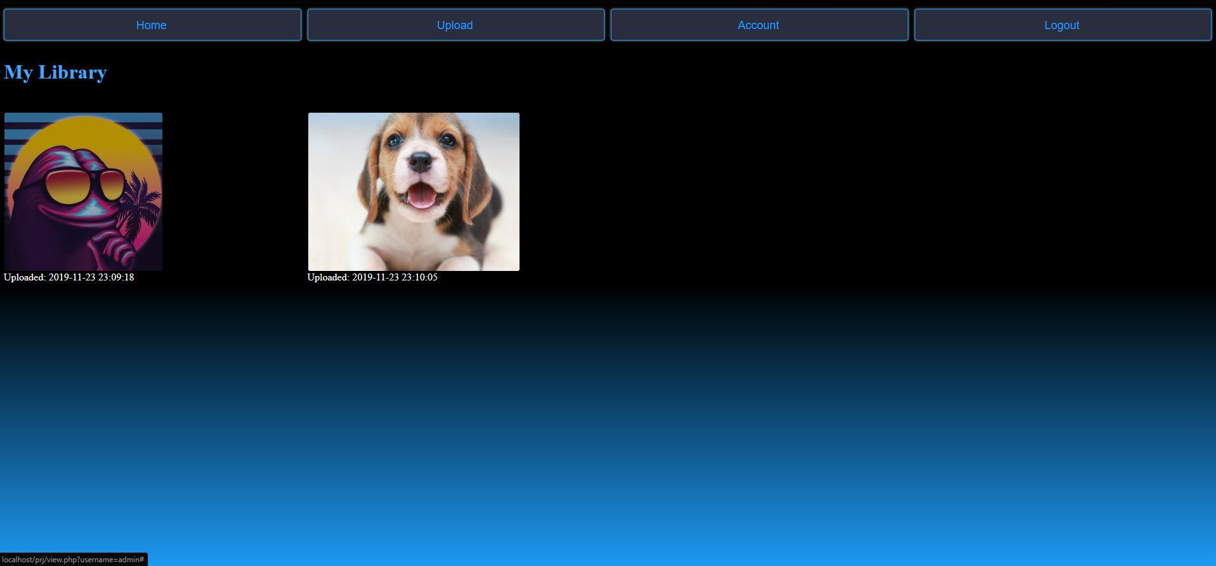

Steven created the css styling for the website. He also created the php documents to upload the images into the database. He worked together with Kyle and David on fixing the view.php bugs where there were a lot of. Steven also helped Kyle with some of the database design because some bugs came up. He did thorough testing of all the functions to ensure that they were all working prior to the demo. Steven helped write up the final report as well.

David created the login page and functionality to make sure users can sign in. David also created the logout and delete account functionality and redirected the user back to create an account screen. He also helped Steven with the view.php bugs because of the amount of them. He also did a thorough testing of all the functionality on the website prior to the demonstration to ensure that everything was good to go. David also helped with the styling for the website to maximize the look of the website. David wrote up the powerpoint and online help document as well as help with the final report.